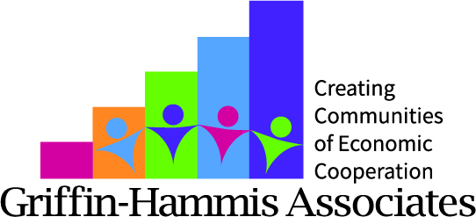

Identifying Vocational Themes - Bill

You’ve met a job seeker named Bill who is 21 years old who’s never had a job. He recently left school and now attends a day activity center for people with developmental disabilities. He lives in a group home where staff knows him pretty well, but mostly through the services they offer him (cooking and cleaning goals, group home outings). He has very minimal contact with his family, and they have not responded to your calls. From a few visits and conversations with Bill and his staff, you’ve learned his interests include:

Professional Wrestling
Playing music on CD, radio
Gadgets, like flashlights, all-in-one tools, clip on mini-lamps, mini voice recorders

We would like to learn enough about not only Bill’s INTERESTS, but also what SKILLS he has that might be related to these interests. We also want to know what TASKS he can complete so that we would know specifically what tasks he can contribute to a work setting. When we get this information all together, we can think about what vocational THEMES we can help Bill explore.

Before assuming that these are Bill’s three vocational themes and should be “job choices” you want to arrange some activities where you can observe Bill participating and discover what skills he has or can be developed in these areas. The purpose of this is to refine the themes based on the information you gather. You want to verify that you’re on track (that these are indeed themes), or what you learn might lead you to broadening the theme (example – “professional wrestling” might be broadened to “entertainment”; Gadgets might be broadened to “working with his hands”).

What are some Activities/Tasks that Bill could do at home that would give context to his interests?

What new activities (in the community) could Bill be involved with that will help explore his interests? What could he actively DO???

What businesses do you know of related to his Emerging Themes where Bill could go visit, tour and speak with (with help, of course!) to learn about their careers and how they got into their line of work?

•Work in pairs or small groups
•Brainstorm activities where you might help Bill with your connections
•Identify nine creative activities that you could help Bill could do to explore his interests, in your community.
•Make sure you identify activities that Bill can actively participate in that show skills.
•Make sure to identify some activities “outside of the usual
Who are some people that you know that Bill can meet, do an Informational Interview with, visit at work, tour their place of business – any or all of these.

Activities/Tasks you could observe Bill doing at home related to his interests

People Bill could meet and interview from your connections

Activities/Tasks in community places Bill could do related to his interests
where he can show what he can do, or where he can learn new skills
(He has DO something not just watch!) Use YOUR community, and YOUR connections

